**FINANCE DATA ANALYSIS**

-- ADD NEW TABLE TOTAL_REVENUE MULTYPLAY STOCK_UNITS AND STOCK_PRICE

SELECT SUM(STOCK_UNITS * STOCK_PRICE) AS TOTAL_REVENUE

FROM BANK

UPDATE BANK SET STOCK_NAME = 'UNKHOWN'

WHERE STOCK_NAME IS NULL

--REMOVE NULL VALUES

SELECT * FROM BANK

WHERE STOCK_UNITS IS NULL OR STOCK_PRICE IS NULL OR STOCK_NAME IS NULL

ALTER TABLE BANK

ADD COLUMN TOTAL_REVENUE NUMERIC

UPDATE BANK SET TOTAL_REVENUE = STOCK_UNITS * STOCK_PRICE

FROM BANK

1. Total Revenue

SELECT SUM(TOTAL_REVENUE)

FROM BANK

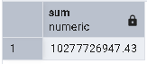

🔹 2. Monthly Revenue Trend

SELECT TO_CHAR(TRANSACTION_DATE, 'YYYY-MM') AS MONTH , SUM(TOTAL_REVENUE) AS REVENUE

FROM BANK

GROUP BY MONTH

ORDER BY MONTH ASC

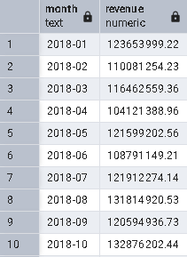

🔹 3. Top 5 Revenue-Generating Customers

SELECT CUSTOMER_ID, SUM(TOTAL_REVENUE) AS REVENUE

FROM BANK

GROUP BY CUSTOMER_ID

ORDER BY REVENUE DESC

LIMIT 5

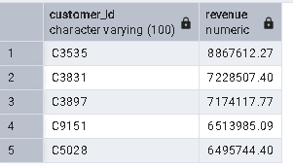

🔹 4. Revenue by COUNTRY

SELECT COUNTRY,SUM(TOTAL_REVENUE) AS REVENUE

FROM BANK

GROUP BY COUNTRY

ORDER BY REVENUE DESC

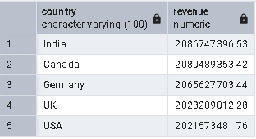

🔹 5. Average Loan Amount

SELECT AVG(LOAN_AMOUNT) AS AVG_LOAN

FROM BANK

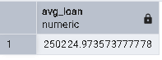

🔹 6. Fraud Transaction Count

SELECT IS_FRAUD , COUNT(IS_FRAUD) AS TOTAL

FROM BANK

GROUP BY IS_FRAUD

ORDER BY TOTAL DESC

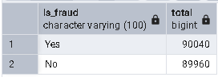

7. Total Transactions

SELECT COUNT(TRANSACTION_DATE)

FROM BANK

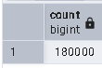

8. Total Transaction Amount

SELECT TRANSACTION_STATUS, SUM(AMOUNT) AS AMOUNT

FROM BANK

GROUP BY TRANSACTION_STATUS

ORDER BY AMOUNT DESC

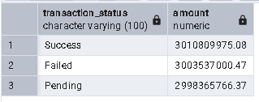

9. Average Transaction Amount

SELECT TRANSACTION_STATUS, AVG(AMOUNT) AS AVG_AMOUNT

FROM BANK

GROUP BY TRANSACTION_STATUS

ORDER BY AVG_AMOUNT DESC

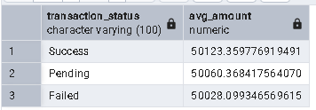

10. Monthly Transactions Trend SUCCESS

SELECT TO_CHAR(TRANSACTION_DATE, 'YYYY-MM') AS MONTH, SUM(AMOUNT) AS AMOUNT

FROM BANK

WHERE TRANSACTION_STATUS = 'Success'

GROUP BY MONTH

ORDER BY AMOUNT DESC

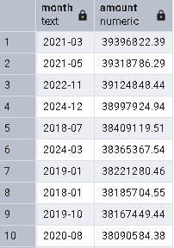

11. Fraud by Channel

SELECT CHANNEL, IS_FRAUD, COUNT(*) AS TOTAL

FROM BANK

GROUP BY CHANNEL, IS_FRAUD

ORDER BY IS_FRAUD DESC

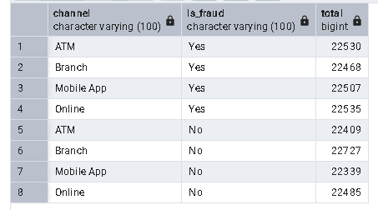

12. Total Loan Amount Issued

SELECT SUM(LOAN_AMOUNT)

FROM BANK

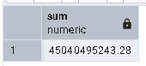

13. Average Loan Interest Rate

SELECT AVG(Interest_RATE) AS Interest

FROM BANK

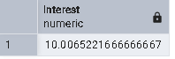

14. Average Credit Score by Country

SELECT COUNTRY, AVG(CREDIT_SCORE) AS AVG_CREDIT

FROM BANK

GROUP BY COUNTRY

ORDER BY AVG_CREDIT DESC

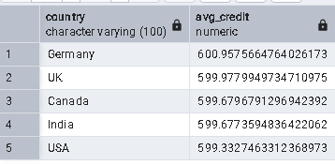

15. Top Stocks Purchased

SELECT COUNT(STOCK_UNITS) AS STOCK

FROM BANK

WHERE STOCK_UNITS >0

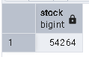

16. Branch-wise Total Transactions

SELECT BRANCH_CODE, SUM(AMOUNT) AS AMOUNT

FROM BANK

GROUP BY BRANCH_CODE

ORDER BY AMOUNT DESC

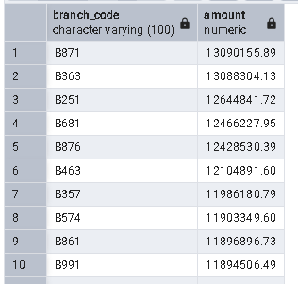

17. Currency-wise Transaction Summary

SELECT CURRENCY, COUNT(*) AS TOTAL_TRANSACTION, SUM(AMOUNT) AS AMOUNT

FROM BANK

GROUP BY CURRENCY

ORDER BY AMOUNT DESC

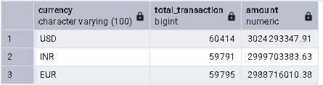

18. Account Type Distribution

SELECT ACCOUNT_TYPE, COUNT(*)AS TOTAL_TRANSACTION

FROM BANK

GROUP BY ACCOUNT_TYPE

ORDER BY TOTAL_TRANSACTION DESC

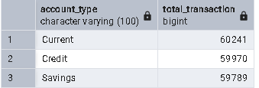

SELECT * FROM BANK